Avidyne IFD 4XX / 5XX Wiring and Configuration
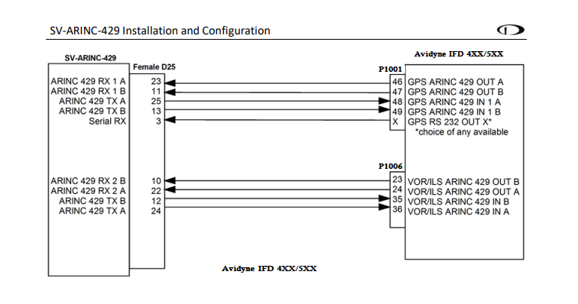
Optional diagram to control and display Avidyne com radio on the SkyView screen.
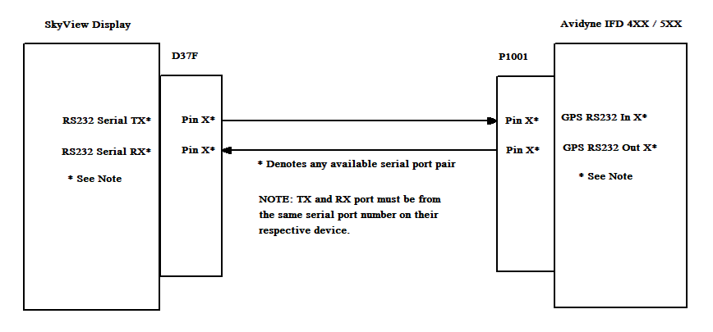

 | Speed | Data
In 1 | High | EFIS/Airdata
In 2 | High | Off
Out 1 | High | GAMA 429 Graphics
Out 2 | High | Off
SDI | Common
VNAV | Enable Labels
Avidyne MAIN ARINC 429 Settings

Avidyne VOR / LOC / GS ARINC 429 Config
 | RX | TX
Speed | High | High
Format | Off | VHF429
SDI | Common
DME Mode | Directed Freq 1

Avidyne Main RS232 Config
 | Input | Output
CHNL # | VhfCtrl | VhfCtrl | Settings for Avidyne Com radio control
CHNL # | Off  (may be used for other devices) | Aviation | Setting for SV-ARINC-429 module RS232 input
Replace # with the port number you wired to the device

SkyView SV-ARINC-429 Settings
MODULE1
INPUT SPEED | HIGH
INPUT1 | GPS1
NAVIGATION SOURCE DISPL NAME | AVI GPS  (name it whatever makes sense to you)
INPUT 2 | NAV1
NAVIGATION SOURCE DISP NAME | AVI NAV  (name it whatever makes sense to you)
OUTPUT SPEED | HIGH
ALLOW AUTO SWITCH | YES
SETUP MENUS > SYSTEM SETUP > ARINC429 SETUP

SkyView RS232 Serial Port Settings for Avidyne Radio Control
SERIAL IN DEVICE | GARMIN / APOLLO SL-30
SETUP MENUS > SYSTEM SETUP > SERIAL PORT SETUP > SERIAL PORT #

